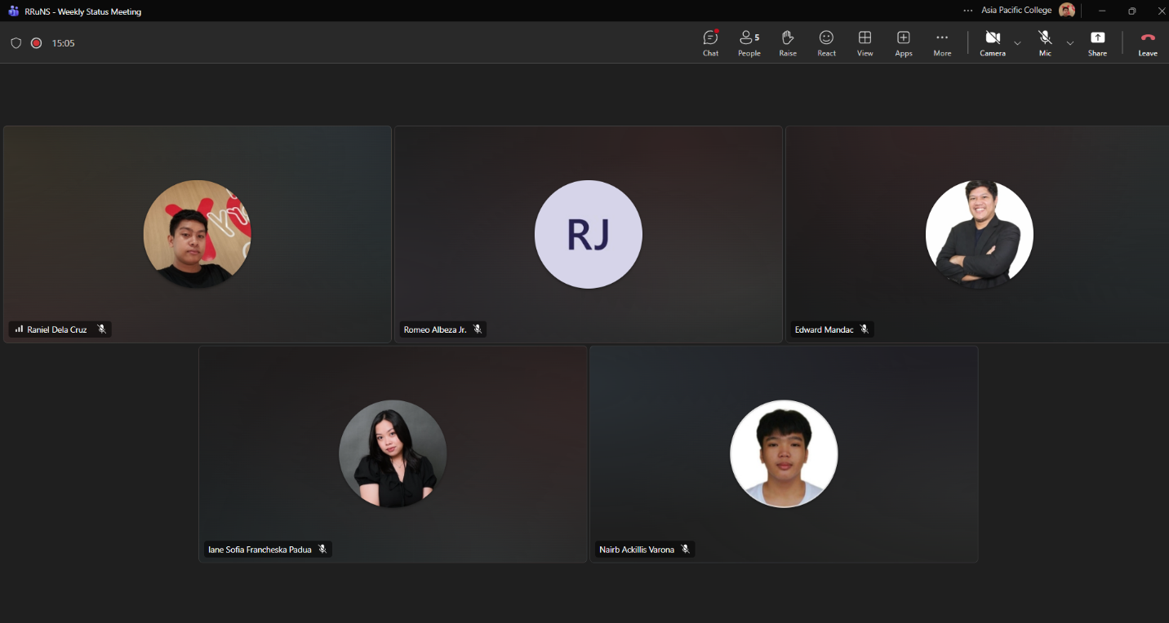
Weekly Status Report: Minutes of Meeting
- Date: Thursday, September 24, 2026
- Meeting Called By: RRuNS Team
- Facilitator: Edward Mandac
- Link of the Meeting: Recap: RRuNS - Weekly Status Meeting Thursday, 24 September | Meeting | Microsoft Teams
1. Attendees
- Nairb Ackillis Varona
- Romeo Jr. Albeza
- Iane Sofia Francheska Padua
- Raniel Q. Dela Cruz
2. Agenda
- Discussion and clarifications of the paper
- Discussion of sprint
3. Summary
- Status update for the week:
  - The team reviewed specific sections of the research paper to address any remaining ambiguities, feedback, or necessary revisions.
  - Held a planning session to discuss the current sprint objectives, monitor task progress, and assign upcoming deliverables for the team.
- Blockers/Obstacle that encountered this week:
  - Coordinating research paper refinements alongside active sprint development tasks to ensure all targets are met.

